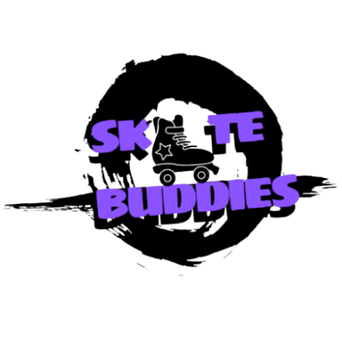
Children and Young People Safeguarding Policy for Community Skating CIC
- Introduction
Skate Buddies UK CIC is dedicated to providing a safe and welcoming environment for children and young people participating in our roller-skating activities, session and events. This policy outlines our commitment to safeguarding and promoting the welfare of children and young people, ensuring compliance with current legislation and best practices.
Copies of this policy should be available to all directors, staff and volunteers, and Skate Buddies UK CIC will not tolerate the abuse of children and young people in the organisation and staff and volunteers should be made aware of how this policy can be accessed.
The organisation recognises that it has a duty to ensure that it carries out all its functions regarding the need to safeguard and promote the welfare of children and young people. (Children Act, 2004, Section 11).
The organisation recognises this duty in relation to all young people regardless of age, colour, race, nationality, ethnic origin, religious belief, social class, gender, sexual orientation or disability.

2. Legal Framework This policy is guided by current legislation, including but not limited to:
- The Children Act 1989 and 2004
- The Childcare Act 2006
- The Children and Social Work Act 2017
- The Working Together to Safeguard Children 2018
- The Keeping Children Safe in Education 2023
- The Safeguarding Vulnerable Groups Act 2006
- The Sexual Offences Act 2003

3. Scope
This policy applies to all staff, volunteers, and anyone involved in Community Skating CIC activities and events where children and young people are present.
4. Policy Statement
Skate Buddies UK CIC is committed to safeguarding and promoting the welfare of children and young people. We aim to ensure that all children and young people can enjoy our activities in a safe environment where they are protected from harm, abuse, and exploitation.
5. Our Commitments
- Safe Recruitment: Implement rigorous recruitment procedures, including DBS checks and references, to ensure the suitability of staff and volunteers.

- Training and Awareness: Provide regular safeguarding training for all staff and volunteers, ensuring they are aware of their responsibilities and know how to respond to concerns.
- Code of Conduct: Establish and enforce a code of conduct for staff and volunteers to ensure professional and safe interactions with children and young people.
- Risk Assessment: Conduct regular risk assessments for all activities and events, implementing measures to minimize risks to children and young people.
- Reporting and Responding: Establish clear procedures for reporting and responding to safeguarding concerns, ensuring that all concerns are taken seriously and addressed promptly.
- Partnership Working: Collaborate with local authorities, safeguarding boards, and other relevant organizations to promote the welfare of children and young people.

6. Responsibilities
- Board of Directors: Ensure the implementation and annual review of this policy.
- Designated Safeguarding Lead (DSL): Oversee safeguarding practices, provide support and guidance to staff and volunteers, and act as the main point of contact for safeguarding concerns.
- Staff and Volunteers: Adhere to the safeguarding policy and procedures, attend training, and report any concerns about a child's or young person's welfare.

7. Implementation and Review
- Training: Deliver safeguarding training during induction and regular updates for all staff and volunteers.
- Communication: Make this policy available to all members and publicize our commitment to safeguarding through our communications and promotional materials.
- Feedback: Encourage feedback from children, young people, parents, and guardians on our safeguarding practices and use this to inform our policy and practices.
- Annual Review: Review this policy annually to ensure it reflects current legislation and best practices.

8. Reporting and Concerns
- Recognising Signs of Abuse: All staff and volunteers should be aware of the signs of abuse and neglect, which may include physical, emotional, sexual abuse, and neglect.
- Reporting Procedures: Any concerns about a child's or young person's welfare should be reported to the DSL immediately. If the DSL is not available, concerns should be reported to the Deputy DSL or another senior member of staff.
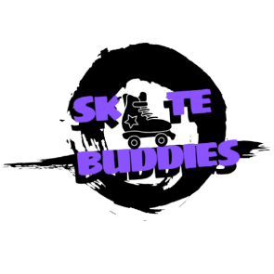
- Confidentiality: All safeguarding concerns will be treated with the utmost confidentiality, and information will only be shared on a need-to-know basis.

If suspicion falls on a member of the Company’s staff

- If an allegation is made about a member of staff, this will be referred to the Social Services Department or safeguarding lead who will make enquiries. This will be linked to the organisation’s disciplinary procedure.

- It will often be necessary to suspend the staff member from involvement in any contact with children on behalf of the company. This action is intended to safeguard the welfare of children and does not assume the guilt of the staff member. The staff member will be given suitable sources of support.
When suspicion falls on a staff member, there are three possible outcomes:
- It may be proved to the organisations satisfaction that the staff member has abused one or more children, or
- It may be proved to the organisations satisfaction that the staff member is not guilty of abuse, or
- The enquiries may be inconclusive, leaving suspicion, but no proof about the staff member’s behaviour.

9. Contact Information For any questions about this policy or to report a safeguarding concern, please contact our Designated Safeguarding Lead Sebrina Brown ADD EMAIL ADDRESS
10. Conclusion Skate Buddies UK CIC is committed to safeguarding the welfare of children and young people. By adhering to this policy, we aim to create a safe environment where all participants can enjoy roller skating free from harm.

Children and Young People Safeguarding Reporting Procedure
1. Introduction This reporting procedure supports the Children and Young People Safeguarding Policy for Skate Buddies UK CIC. It outlines the steps to be followed when a safeguarding concern arises, ensuring prompt and effective action to protect children and young people.

2. Recognising Signs of Abuse and Neglect Staff and volunteers should be vigilant and aware of the signs of abuse and neglect, which may include:
Physical Abuse
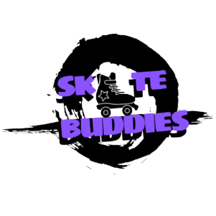
Physical abuse may involve hitting, shaking, throwing, poisoning, burning or scalding, drowning, suffocating or otherwise causing physical harm to a young person. Children and young people are subject to injuries as part of everyday life, the challenge for workers is to differentiate accidental from non-accidental injuries.
Factors to consider in deciding whether a physical injury might be accidental or inflicted include:
- Where on the body is the injury? Accidental injuries tend to occur on parts of the body that protrude (e.g. shins, knees, hips, elbows, forearms and chin). Injuries to the neck, trunk, genital area, face and behind the ears merit further inquiry.
- What shape is the injury? Be aware of linear injuries that may have been caused by an object such as a cane or belt. Some implements leave a clear outline. There may also be evidence of finger or handprints.
- Is the injury symmetrical? In other words, is it the same on both sides of the body? This may indicate a gripping and/or shaking injury.
Other factors to consider:
- Can the young person offer an explanation for the injury?
- Does the explanation seem plausible?
- Does the young person seem afraid or evasive about the injury?
- Is the young person trying to cover up the injury with clothing etc?

Emotional Abuse:
Emotional abuse is the persistent emotional maltreatment of a young person such as to cause severe and persistent adverse effects on their emotional development like being excessively withdrawal, fearful, or anxious. This may include:
- Conveying to the young person that they are worthless, unloved or inadequate
- Valuing the young person only insofar as they meet the needs of another person
- Imposing age or developmentally inappropriate expectations on the young person
- Seeing or hearing the ill treatment of another
- Serious bullying causing the young person to feel frightened or in danger
- The exploitation or corruption of young people
.
Sexual Abuse
Sexual abuse involves forcing or enticing a young person to take part in sexual activities, whether or not they are aware of what is happening. This may include:
- Physical contact of a penetrative kind such as rape, buggery or oral sex
- Physical contact of a non-penetrative kind such as masturbation of the young person
- Non-contact activities such as involving young people in looking at, or in the production of pornographic materials. It may also involve the young person watching sexual activities
- Encouraging the young person to behave in sexually inappropriate ways
- Inappropriate sexual behaviour or knowledge
- Physical signs of abuse.

Neglect:
Neglect is the persistent failure to meet a child’s basic physical and/or psychological needs, likely to result in the serious impairment of the young person’s health or development.
This may include:
- Failing to provide adequate food, clothing and shelter
- Exclusion from home or abandonment
- Failing to protect a young person from physical and emotional harm or danger
- Failure to ensure adequate supervision (including the use of inadequate caregivers)
- Failure to ensure access to appropriate medical care or treatment
- Neglect of, or unresponsiveness to, basic emotional needs

3. Immediate Action
If a child or young person is in immediate danger, contact emergency services immediately (999). Ensure the safety of the child or young person while waiting for help to arrive.

4. Reporting Procedure
When a safeguarding concern is identified, the following steps must be taken:

Step 1: Report the Concern
- Who to Report To: Report the concern immediately to the Designated Safeguarding Lead (DSL). If the DSL is unavailable, report to the Deputy DSL or another senior staff member.
- How to Report: Concerns should be reported verbally and followed up in writing within 24 hours. Use the Safeguarding Concern Report Form to document the details.

Step 2: Document the Concern
- Record Details: Include all relevant information, such as the child's or young person's name, age, and contact details; the nature of the concern; any physical or behavioural indicators observed; and the date, time, and location of the incident.
- Confidentiality: Keep the report confidential and share it only with those who need to know.

Step 3: Initial Assessment
- DSL Assessment: The DSL will assess the concern to determine the appropriate course of action. This may involve gathering additional information, consulting with other professionals, and considering the immediate safety of the child or young person.

Step 4: Action Plan
- Internal Action: The DSL will decide whether the concern can be managed internally through support and monitoring or if it requires external intervention.
- Referral to External Agencies: If the concern meets the threshold for external intervention, the DSL will refer the case to the local authority children's social care services, following local safeguarding procedures. In cases of suspected criminal activity, the police will also be informed.
- Parental Involvement: Where appropriate and safe, parents or guardians will be informed of the concern and the actions being taken, unless doing so would put the child or young person at further risk.

Step 5: Follow-Up and Monitoring
- Ongoing Support: The DSL will ensure that the child or young person receives appropriate support and monitoring following the initial report. This may include liaising with external agencies, arranging counselling, or providing additional supervision during activities.
- Record Keeping: Maintain detailed and secure records of all actions taken, communications, and outcomes related to the concern. These records should be kept confidential and stored securely.

Step 6: Review and Reflect
- Review of Actions: The DSL will review the actions taken to ensure they were appropriate and effective. Feedback will be sought from all parties involved to identify any lessons learned.
- Policy Review: Findings from the review will inform the annual review of the safeguarding policy and procedures to ensure they remain effective and up to date.
Dealing with a young person who is making a disclosure
If a young person tells you that they, or another young person, are being harmed you MUST NOT INVESTIGATE. Where possible, you should involve the DSL.
In all instances, you should adhere to the following principles:
- Listen and take seriously what the young person says
- Do not make any promises about keeping the information secret
- Be calm and reassuring
- Do not express disbelief, however incredible the story appears
- Obtain sufficient information from the young person to inform what you need to do next but do not investigate by asking questions
- Explain to the young person what will happen next. Tell them that you will pass the information on to someone who can help
- Don’t make assumptions about the young person’s feelings
- Avoid condemning the alleged abuser
- Reassure the young person that he/she is not responsible for what has happened despite what they might have been told
- Write down what has been said immediately afterwards using the young person’s own words as far as possible. Record what you said in response

Contact Information
For reporting safeguarding concerns, contact:
- Designated Safeguarding Lead (DSL): Sebrina Brown [Contact Information]
- Deputy DSL: Delroy Thomas, [Contact Information]
- Local Authority Children's Social Care: [Contact Information]
- Police (in case of emergency): 999

Conclusion
The safety and welfare of children and young people are of paramount importance. By following this reporting procedure, Community Skating CIC aims to ensure that safeguarding concerns are handled promptly and effectively, protecting the well-being of all participants.
Approved by: Empress Gibbs, Director 5th August 2024
Next Review Date: [One year from approval date]

